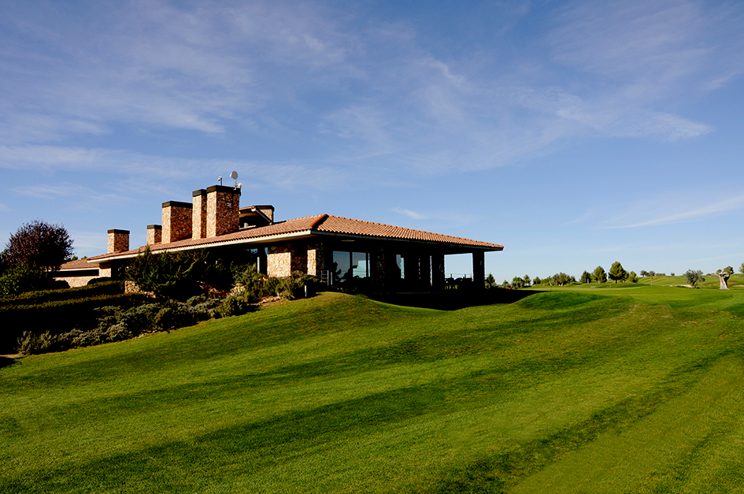

Albacate Pairs Challenge – 26-27th August 2020
Presented by Albatross Golf Tours at Las Pinaillas Golf Course
For 2020 we have the following options available for this popular 2 day event at the beautiful Las Pinaillas Golf Club
Option 1 (Standard Package) – 1 Night in Castilla Hotel (2*) in Albacete
2 Rounds of golf at Las Pinailas Golf with buggies included and Meal after Golf on Day 2
115€ in Shared Room or 130€ in single
Option 2 (Standard Package +) - 1 Night in Los Llanos Hotel (4*) in Albacete
As above but in 4* Hotel – 140€ in shared room or 170€ in single
Option 3 (2 Nights 2* ) - 2 Nights in Castilla Hotel (2*) in Albacete
As Option 1 but extra night in hotel – 142€ in shared accommodation or 172€ in single
Option 4 (2 Nights 4*) - 2 Nights in Los Llanos Hotel
As option 2 but extra night in hotel – 195€ Shared or 250€ in single
Format of the day is a pairs betterball stableford – Past Winners
2012 Winners – Steve Ansell & Dave Lee 2013 Winners – Mike Hope & Rab Melrose
2014 Winners – Dave Friedman & Ernie Lucas 2015 Winners - Andy Hadder & Andy Kirkwood
2016 Winners – Les Cox & Mick Riley 2017 Winners – Steve Ansell & Andy Hadder
2018 Winners – Steve Ansell & Andy Hadder 2019 Winners – Steve Ansell & Gary Cornforth

